CRU’s 11th Cable Conference to focus on challenging times ahead
30 Mar 2017
Topic: Conferences
International cable news, analysis and forecast provider, CRU, is to hold its 11th Wire & Cable Conference in Munich, Germany at the Westin Grand Hotel from July 17-19.
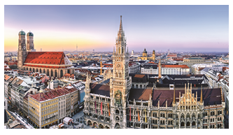
The location in Germany, Europe's powerhouse and key renewables, automotive and technology innovation provider is an ideal setting to discuss the challenges and opportunities faced by the international energy and communication cables industry.
Germany has emerged as a world renewable energy leader, which makes the country the perfect place to understand the future of wire and cable consumption in power generation. Bavaria is also of course the hub for car manufacturing, so it is apt that the conference looks at the issue of the connected car, autonomous driving and automotive electronics.
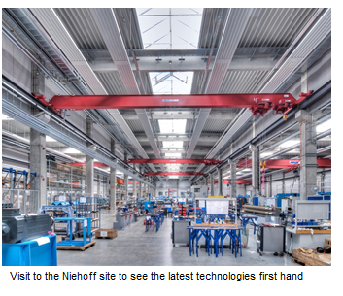
The wire and cable industry operates in uncertain times, with often unexpected results, which offer both great challenges and opportunities. Discussions will focus on the implications of trade, political and regulatory changes in the US and the UK on the global wire and cable market. The Construction Products Regulation (CPR) will also become mandatory in the month that the conference takes place. This time CRU will look at what steps the industry should take to keep up with European regulations and how will it affect the global construction cable market. Other challenges are how the optical fibre and cable industry can prepare for the arrival of 5G and increasingly smart, connected and data heavy lifestyles.
"We are really excited about the conference this year. It is such an exciting time for the wire and cable industry," said Nicola Coslett, CEO of CRU Events. "As with previous years, the event will open with shared plenary sessions and then split into streams that drill down separately on Energy cable and Communication cable issues. In this way, we bring together the entire supply chain from across global wire and cable industry. Opening sessions will explore the key regional markets and the economic factors affecting wire and cable trade flows," Coslett explained.
The event will have over 30 presentations packed into a two day programme, in addition to a site visit to the Niehoff plant. There will be a number of in-depth papers on copper, aluminium, optical fibre, coatings and other inputs markets, as well as a showcase of the latest technical innovations that may disrupt this sector.
For details about the event visit www.wireandcableconference.com

Contributor: Natalie Noor- Drugan, Publisher & Editor in Chief, Wire & Cable News

